Fort Vancouver Mobile app walk-through (May 11, 2011)
Kanaka module (initial public release date: June 18, 2011)
Location: Fort Vancouver National Historic Site’s village

1. App is downloaded through public markets (Android/Apple)

2. App loads and presents this screen:
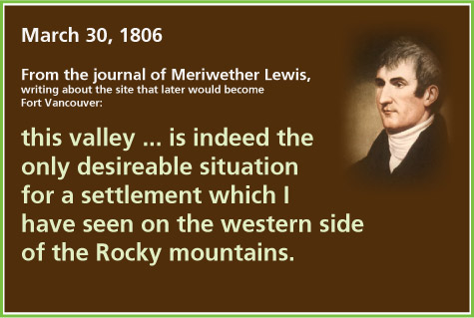

3. User touches screen and this screen appears:
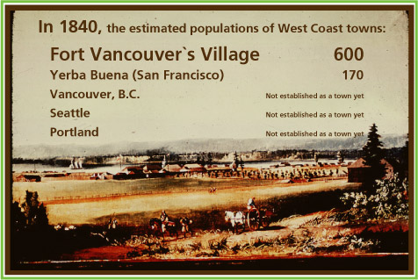
4. User touches screen and this animation plays: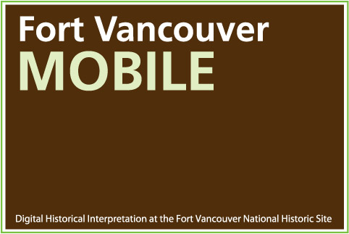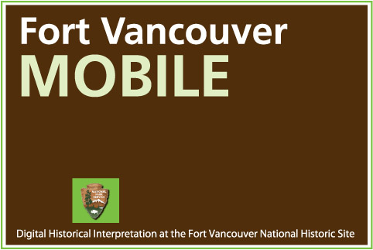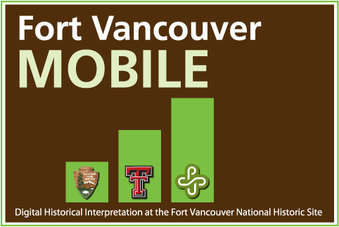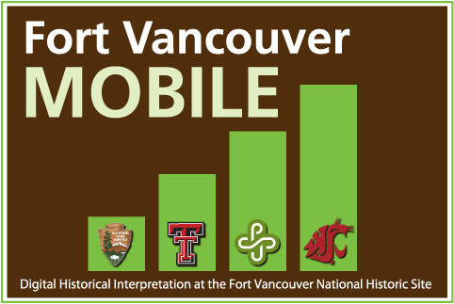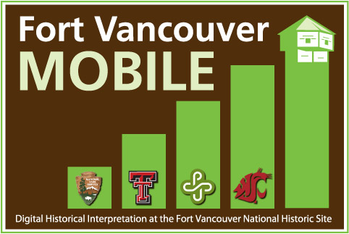
5. User touches screen and module selection screen appears (buttons coded separately):
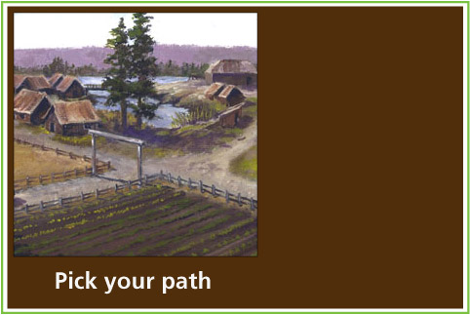
For June 18: The three buttons should say:
The Village opens
Kanaka
Kane’s Wanderings (preview)
The Kane’s Wanderings preview might or might not be done by the June 8/June18 beta testing and launch. So we will need to be prepared to pull/disable that button, if needed. The other two should be complete and fully functional by June 8.
6. Kanaka button is pressed by user, main search screen appears, with the text prompt coded underneath of, “Explore around the “A Community of Cultures” sign:
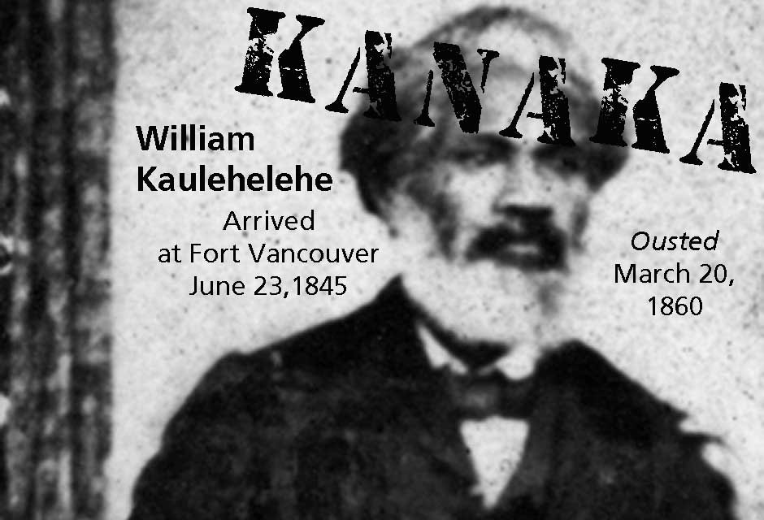

7. When user reaches the sign (GPS coordinate: 45*37.347N, 122*40.024W), the Shine intro video is pushed to the phone.

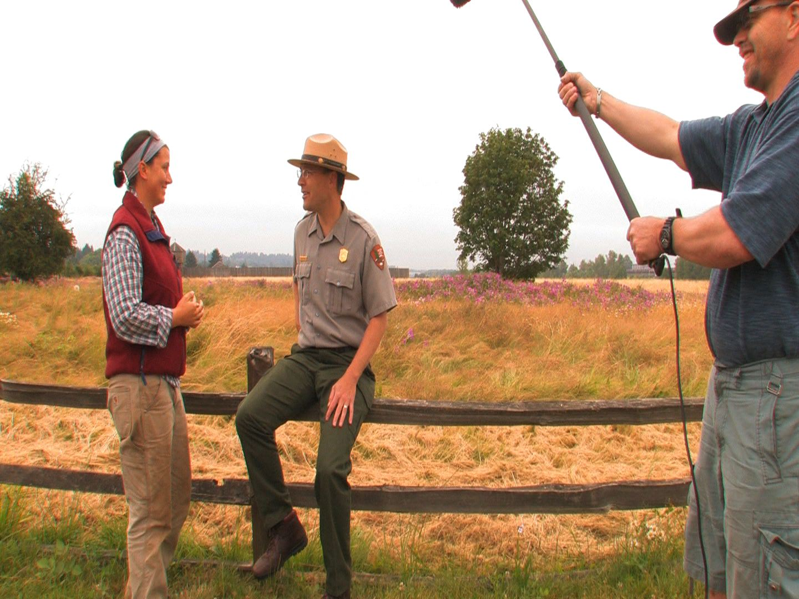

8. User is asked through a text box interaction, “What do you think they found?” Submission is sent to server for collection and publication on web-based site. Also shows user what the last few people guessed (not coded yet). Video two is unlocked.
After this video plays and the user input is received, the following quick animation should appear, showing that the video (and submission?) has been placed in the user’s “haversack,” to take home and share with friends (it says here to press the menu button to reach the haversack; if that is going to change in the PhoneGap version/Apple version, or alternative wording is needed, let’s make sure to update that. Each time media is pushed to the phone, the quick animation should play to remind the user that this media has been given to them to keep on their phones and, at least potentially, to share with others.
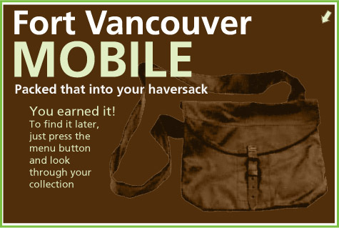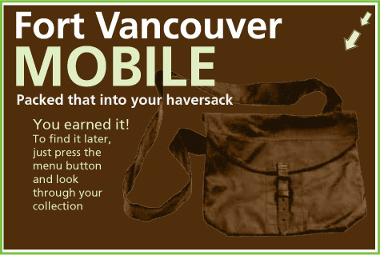

9. User is returned to Kanaka main search screen, with text prompt underneath saying: “Walk west, toward the barbed-wire U.S. Army fence.”
10. At the first fence line (GPS coordinate: 45*37.352N, 122*40.063W), Wilson in the pit video is pushed to user:

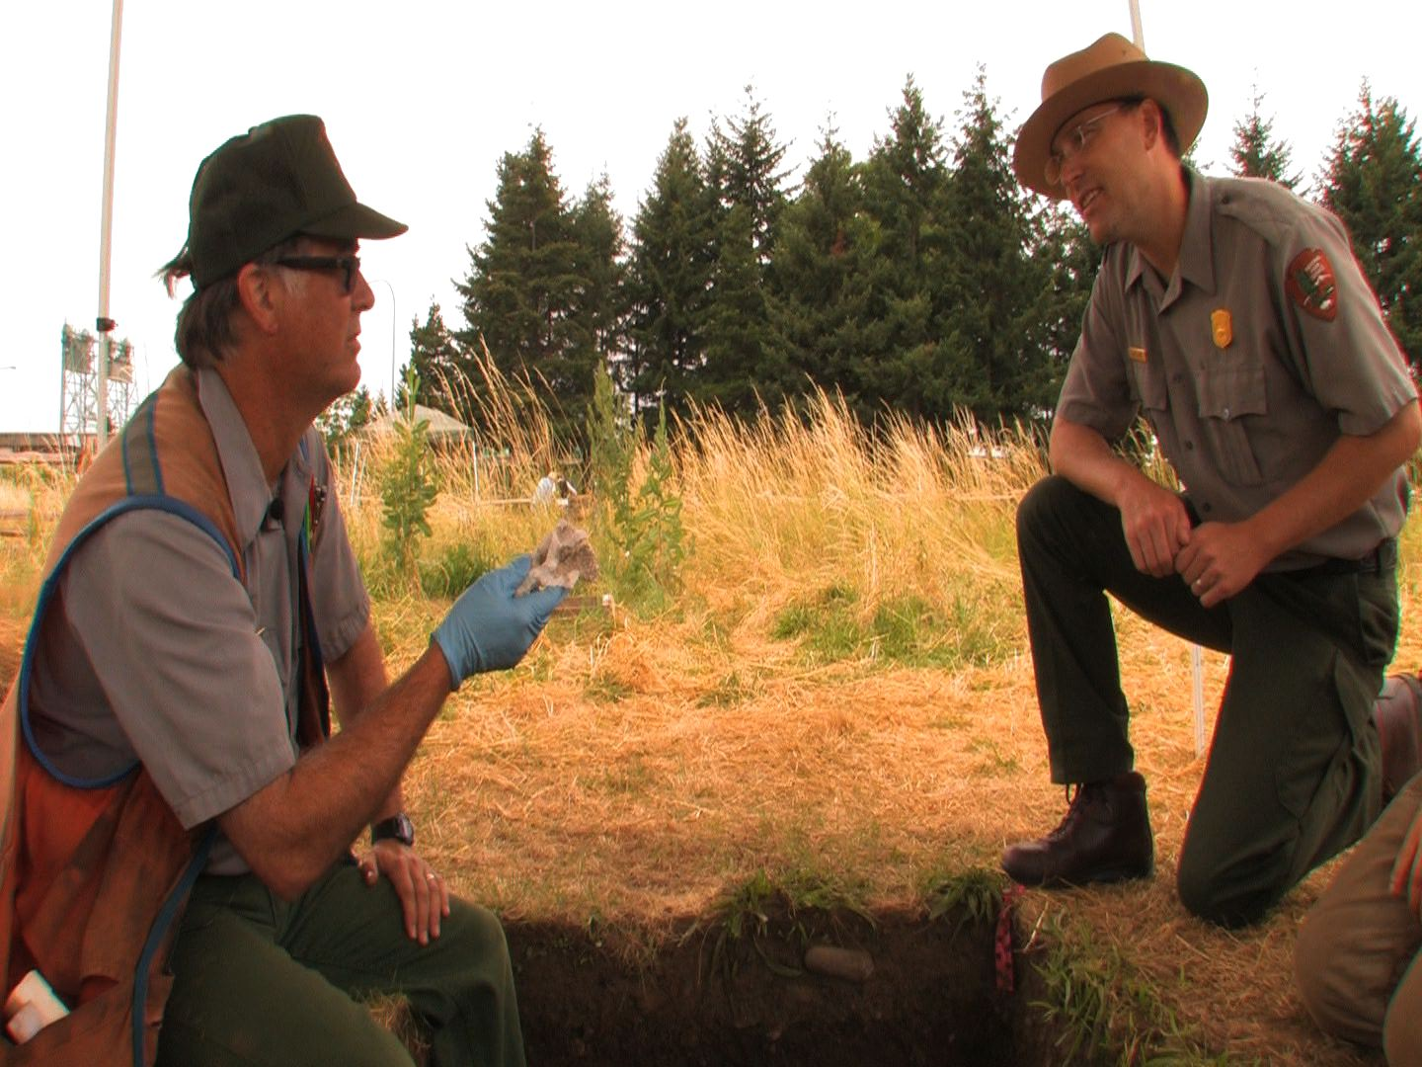

11. User is asked through a text box interaction: “What item do you own that reminds you of home?” Submission is sent to server for collection and publication on web-based site. Also shows user what the last five people guessed (not coded yet). First Twitter-Graph is unlocked; Haversack animation plays.

12. User is returned to Kanaka main search screen, with text prompt underneath saying: “Walk west, toward the barbed-wire U.S. Army fence.” Between the two reconstructed houses, (GPS coordinate: 45*37.355N, 122*40.091W), the first Twitter-like exchange (dubbed a Twitter-Graph) among historical characters begins (users swipe to move from screen to screen) / Video 3 is unlocked:

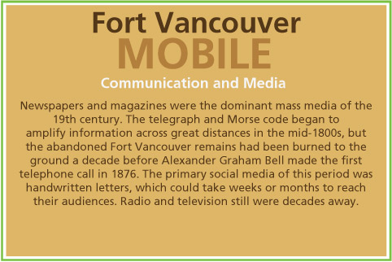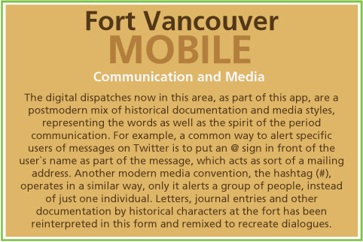
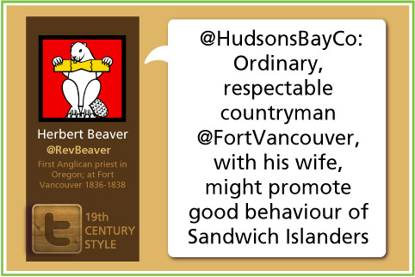
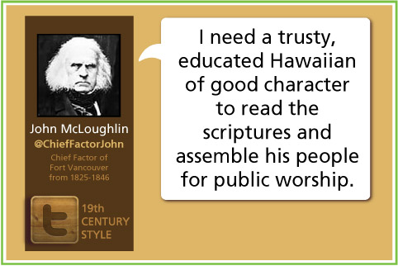
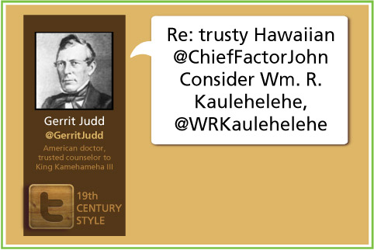
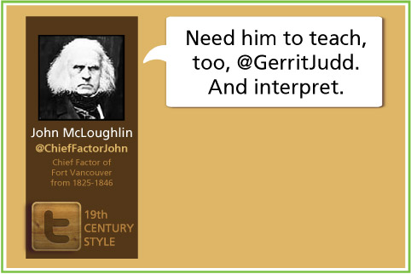
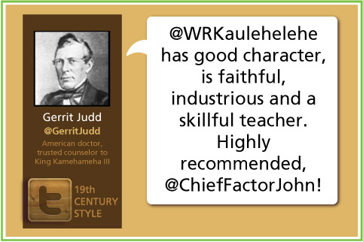
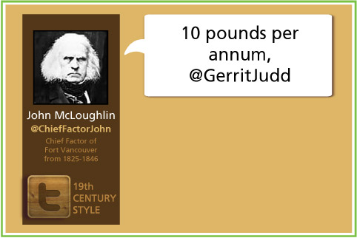
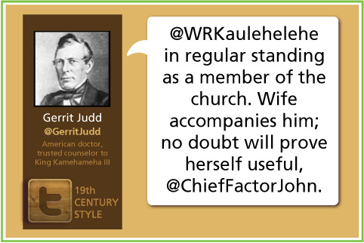
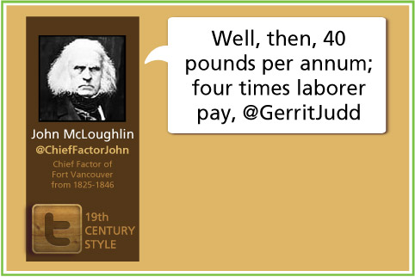
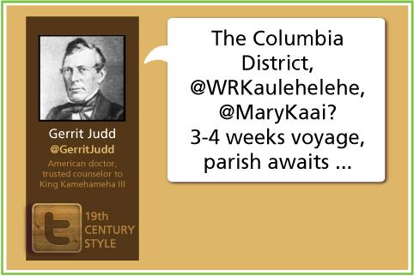
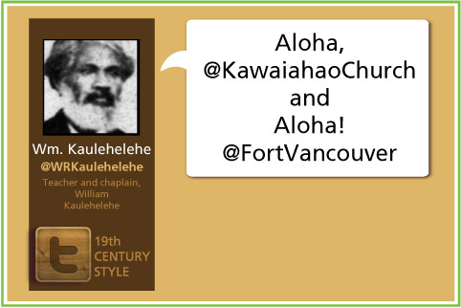
Haversack animation plays.
13. User is returned to Kanaka main search screen, with text prompt underneath saying: “Walk west, toward the barbed-wire U.S. Army fence.” Near the fence at the end of the path, the William arrives video plays (GPS: 45*37.357N, 122*40.107W).

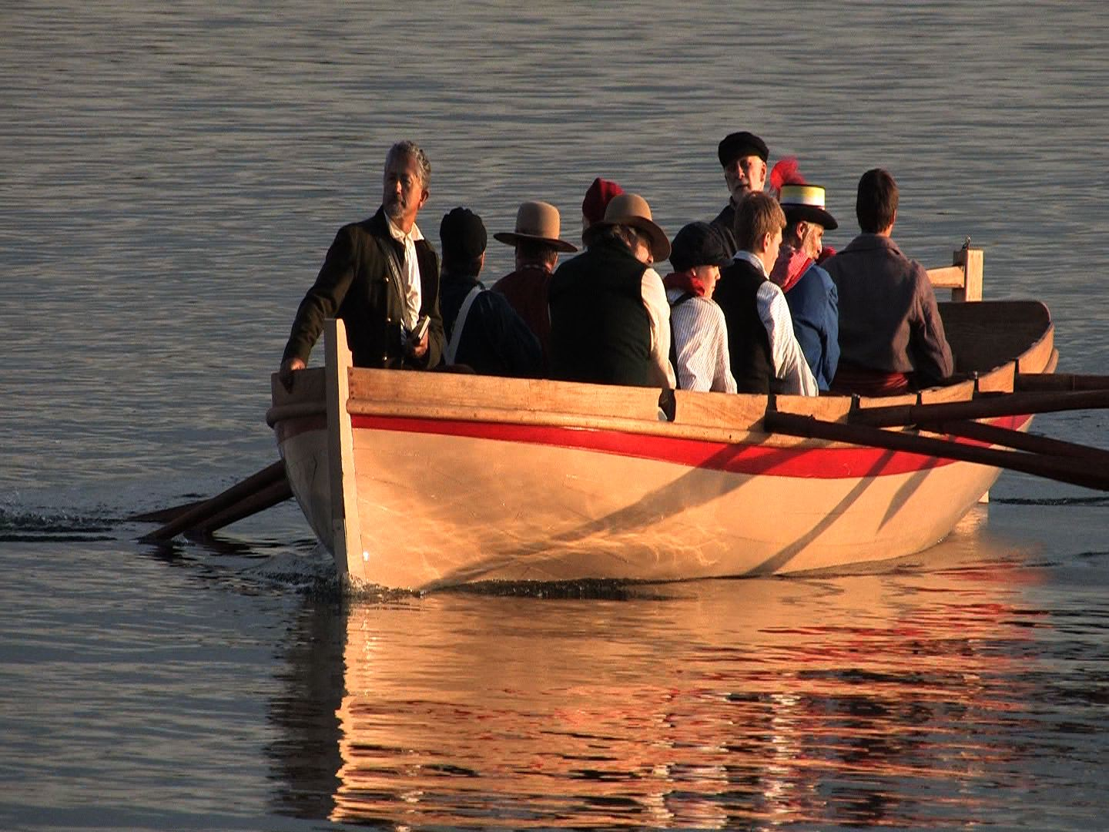

14. Interaction prompt: Document your arrival at Fort Vancouver’s Village. Camera enacted, photo taken, image sent to server for collection and publication on the companion web site, plus slideshow of last five images added (not coded yet). Haversack animation plays.
15. User is returned to Kanaka main search screen, with text prompt underneath saying: “Search around the houses.” As user walks toward first house, the William writing video begins (GPS: 45*37.355N, 122*40.091W).

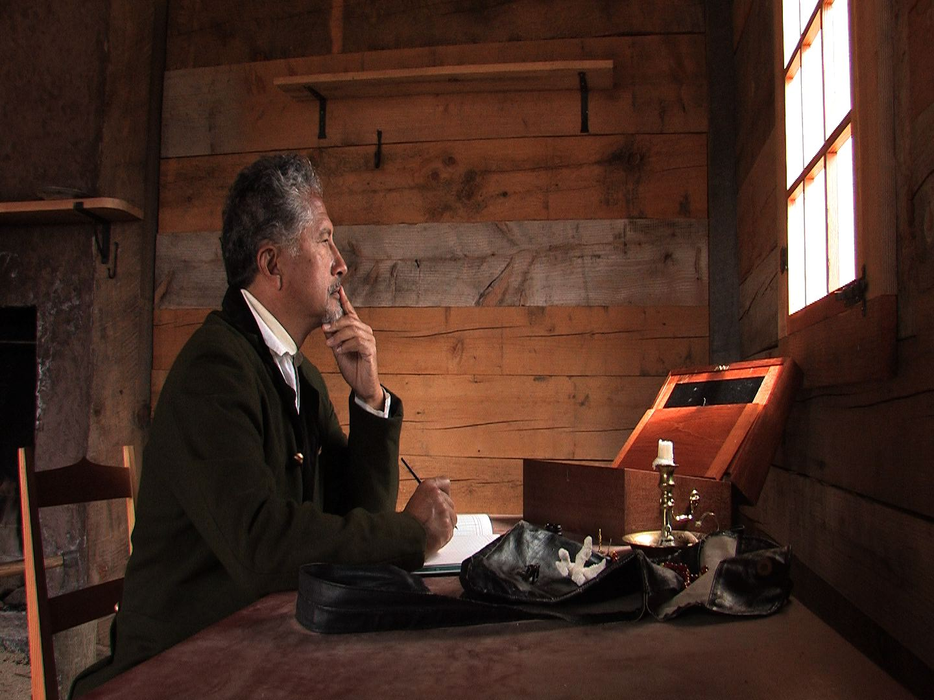

16. Interaction: (Need to work on the concept of this one as the coding develops) William is not getting his newspapers, the primary media source of the period. He wrote a letter. If someone shut off the Internet, what kind of video response would you try to post? Create the video, submit, filter and post. Newspaper nodes are unlocked. Haversack animation plays.

17. User is returned to Kanaka main search screen, with text prompt underneath saying: “Search around the houses. Find William’s newspapers.” As user walks up path at first house, another Twitter message appears (GPS: 28: 45*37.360N, 122*40.091W):

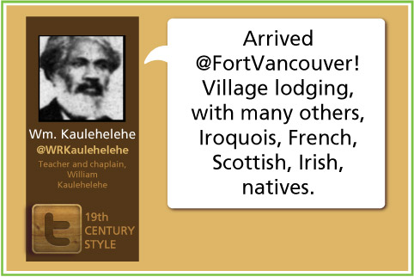
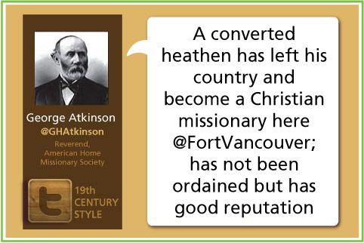
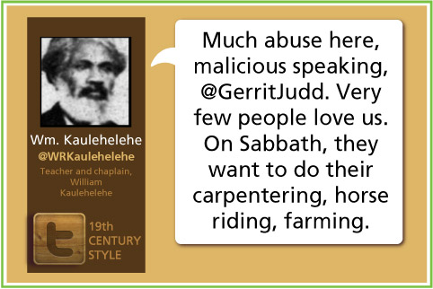
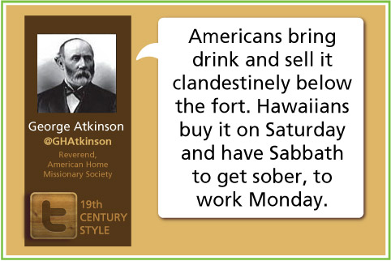
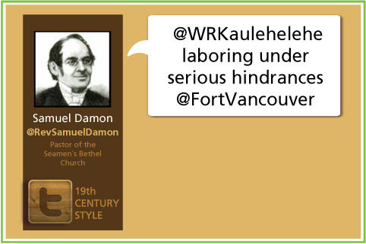
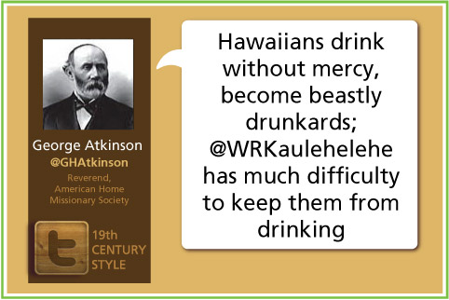
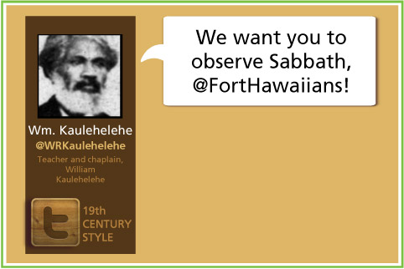
Haversack animation plays.
18. User is returned to Kanaka main search screen, with text prompt underneath saying: “Search around the houses. Find William’s newspapers.” As user walks to the back of the first house (GPS: 45*37.370N, 122*40.087W), another Twitter message appears:

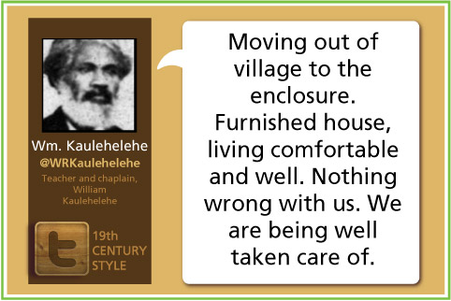
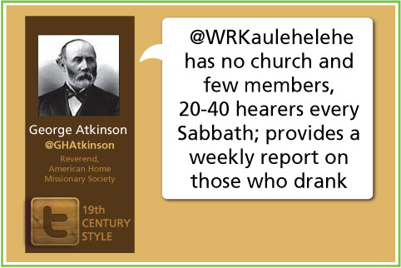
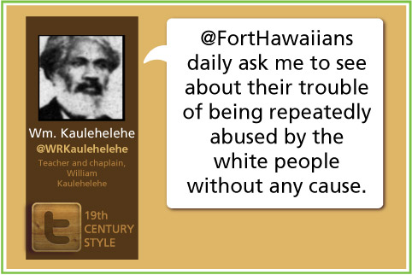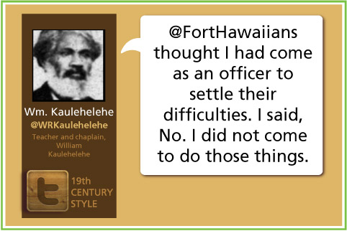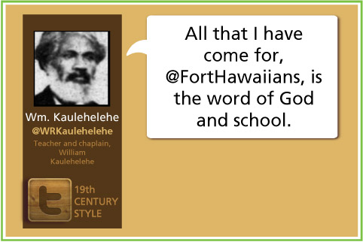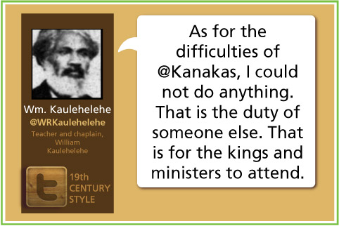
Haversack animation plays.
19. User is returned to Kanaka main search screen, with text prompt underneath saying: “Search around the houses. Find William’s newspapers.” When user gets to the east side of House 2 (GPS: 45*37.360N, 122*40.067W), the final Twitter message appears: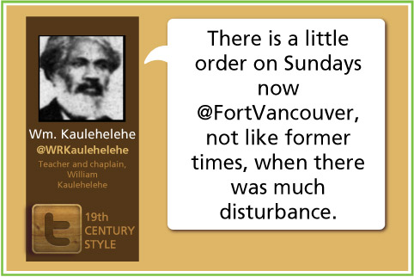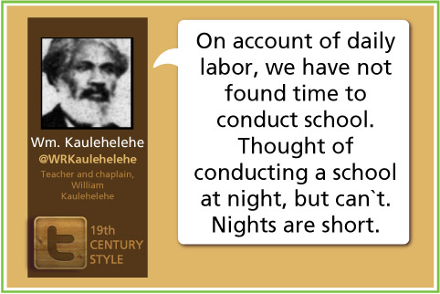
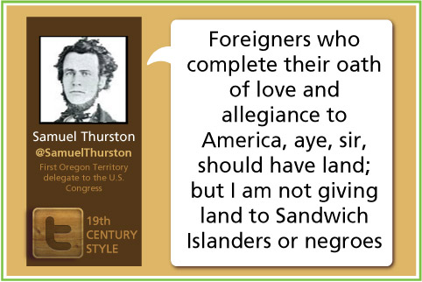

20. Interaction. User is asked advice you would give William? Comment is captured, filtered and published, per the earlier MO. Haversack animation plays.

21. User is returned to Kanaka main search screen, with text prompt underneath saying: “Search around the houses. Find William’s newspapers.” As user walks to House 2, and then around it, the following quizzes appear

22. INTRO/DICKENS, in front of House 1 (GPS: 45*37.363N, 122*40.088, with answers coded into the screen):
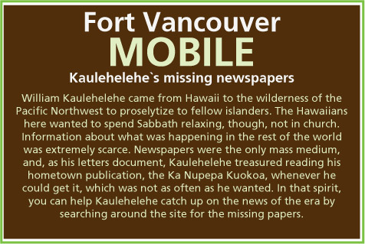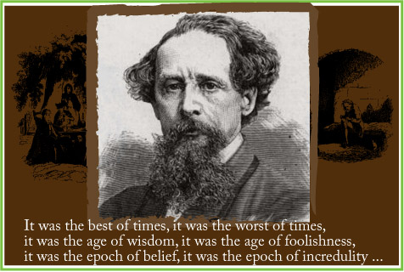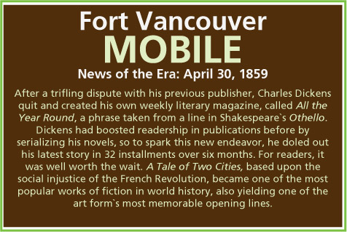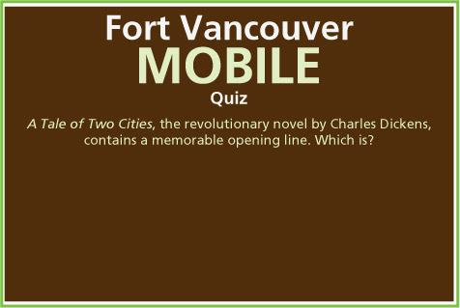
A Tale of Two Cities, the revolutionary novel by Charles Dickens, contains a memorable opening line. Which is?
A. It was the best of times, it was the worst of times,
B. A screaming comes across the sky.
C. Call me Ishmael.
D. It was a dark and stormy night.
With each of these quizzes, the submission is tabulated on the complementary web site, as a wisdom of the crowds sort of thing.

POE (On path, in front of House 2, GPS: 45*37.353N, 122*40.071W):
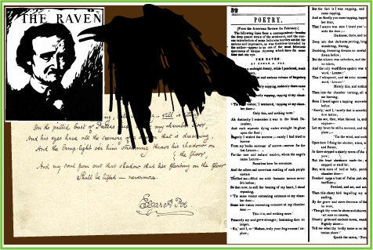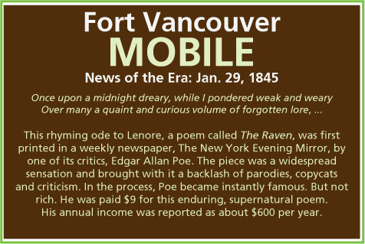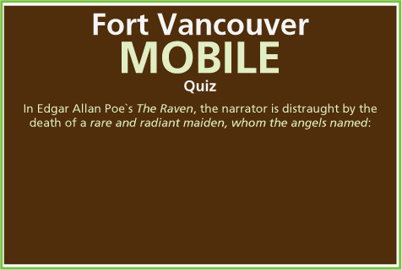
In Edgar Allan Poe’s “The Raven,” the poet is distraught by the death of a “rare and radiant maiden, whom the angels named”:
A. Rowena
B. Camille
C. Ligeia
D. Lenore

LINCOLN (East side of House 1, GPS: 45*37.367N, 122*40.084W):
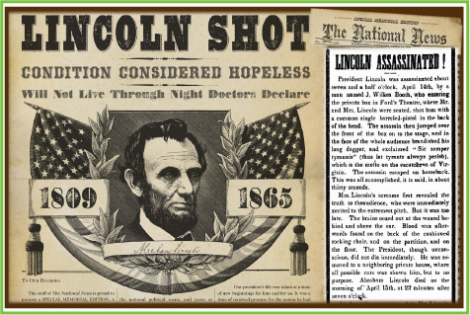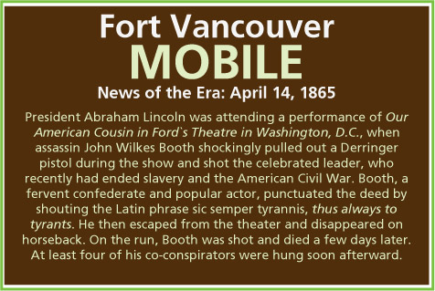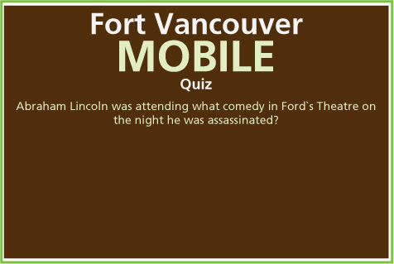
Abraham Lincoln was attending what comedy in Ford’s Theatre on the night he was assassinated?
- A Midsummer Night’s Dream
- Our American Cousin
- The Pirates of Penzance
- The Importance of Being Earnest

BASEBALL (west back side of House 1; GPS: 45*37.373N, 122*40.091W):
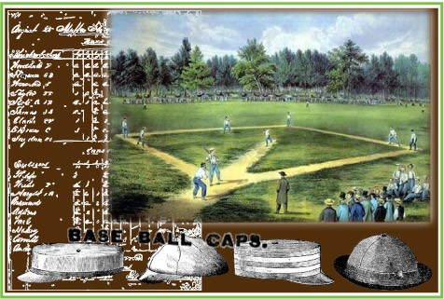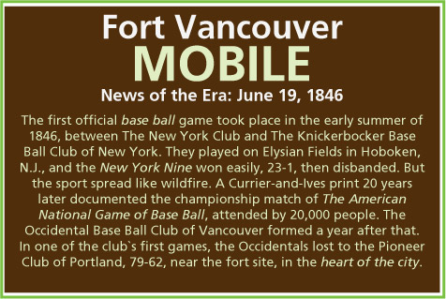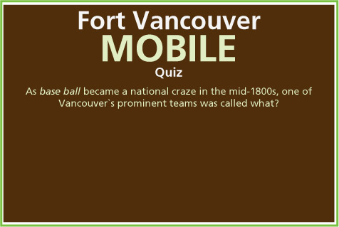
As base ball became a national craze in the mid-1800s, one of Vancouver`s prominent teams was called what?
- The Pioneers
- The Occidentals
- The Knickerbockers
- The New York Nine

NAST (Chimney area of House 2, 45*37.365N, 122*40.068W):
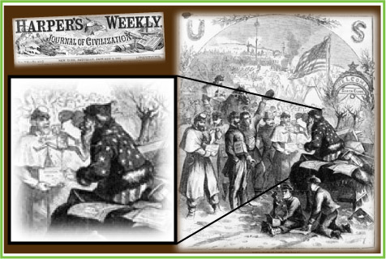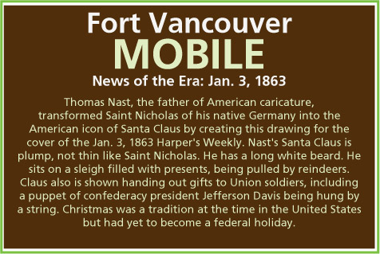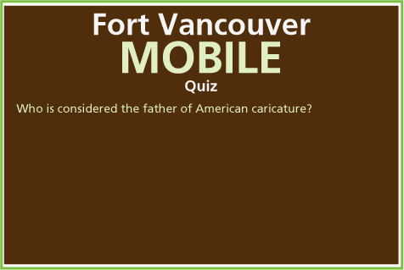
Who is considered the father of American caricature?
- Jefferson Davis
- Nicholas Harper
- Thomas Nast
- John McLoughlin

SULTANA (West rear side of House 2, 45*37.365N, 122*40.071W):
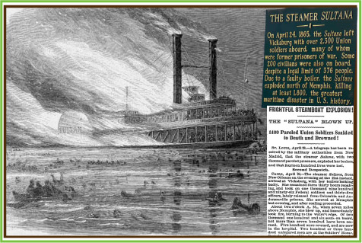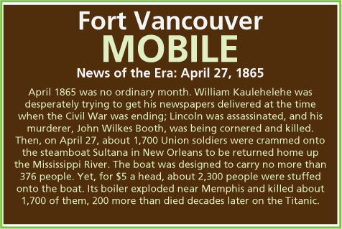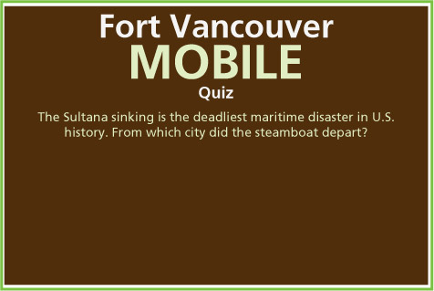
The Sultana sinking is the deadliest maritime disaster in U.S. history. From which city did the steamboat depart?
- Memphis
- New Orleans
- Birmingham
- Knoxville

23. After the quizzes are all taken, the final confrontation video is unlocked:

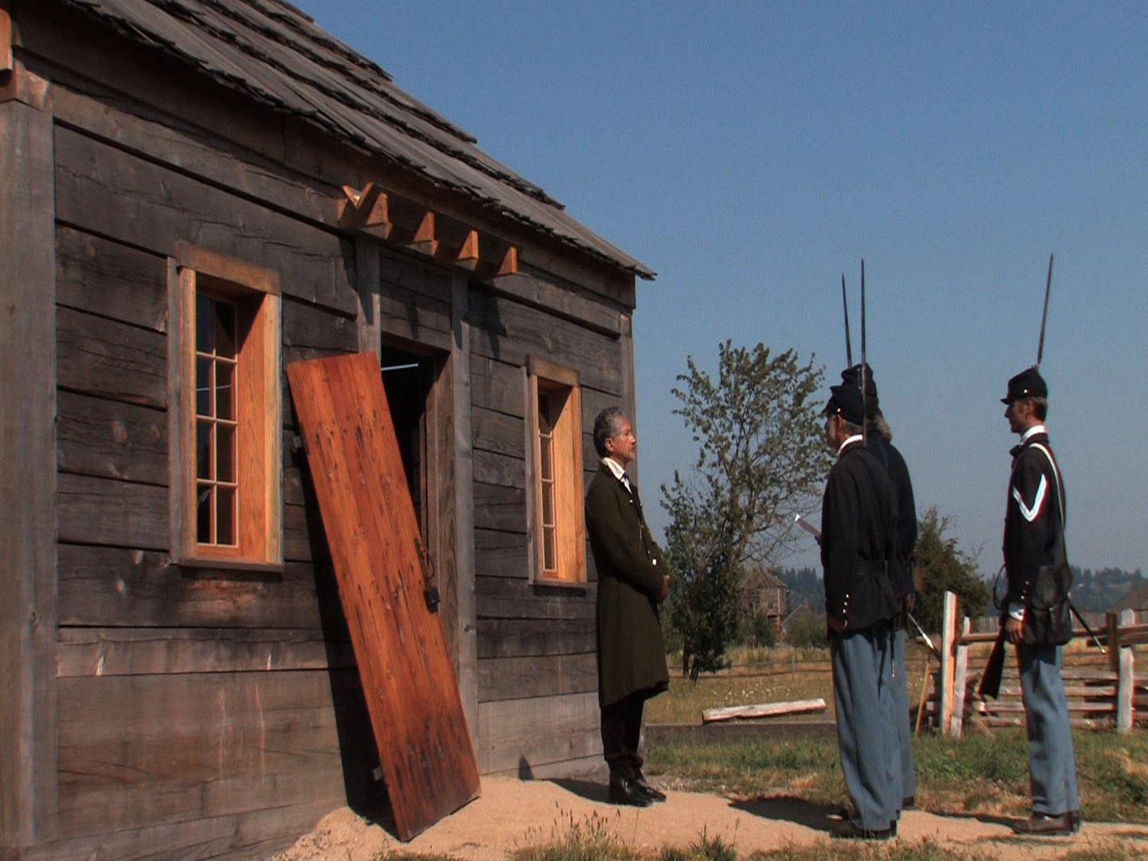

24. User is returned to Kanaka main search screen, with text prompt underneath saying: “Search around the houses.” As user walks back to the front of the second house again, (Front of House 2, GPS: 45*37.358N, 122*40.070W), the final video plays:
25. Credits roll:
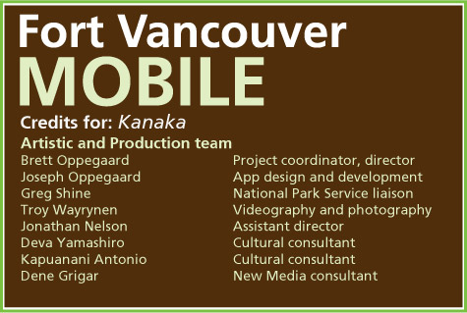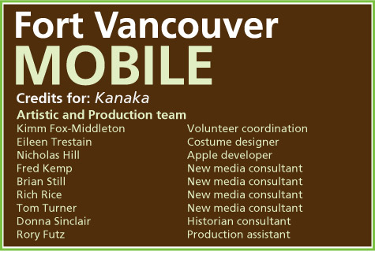
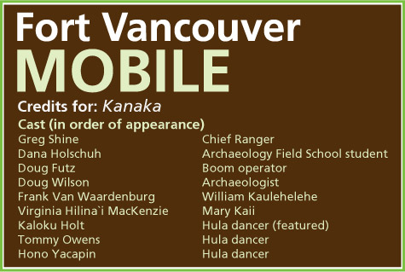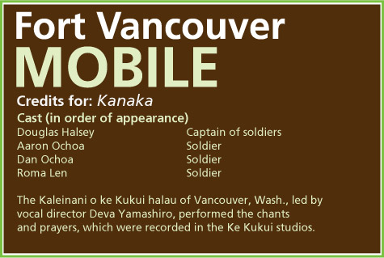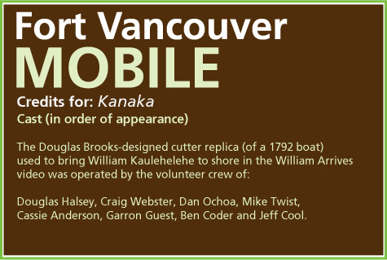
26: To be added later in the summer of 2011: Hula video (on the side path between the main path and House 1; GPS: 45*37.360N, 122*40.091W)
